UAS Data Visualization – IPEDS
Andhika Karunia Rizqi Setyawan – 6DT 1
https://public.tableau.com/views/UASDataVisualization-IPEDS/Story1?:language=en-US&:sid=&:redirect=auth&:display_count=n&:origin=viz_share_link
SHEET 1
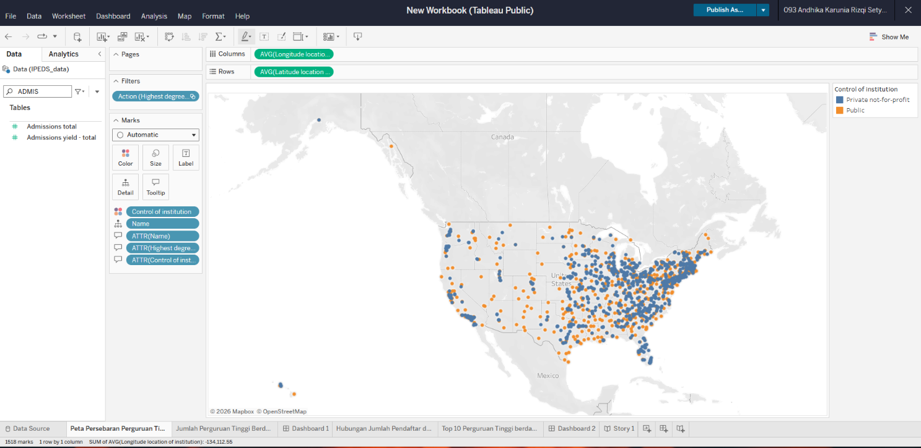

SHEET2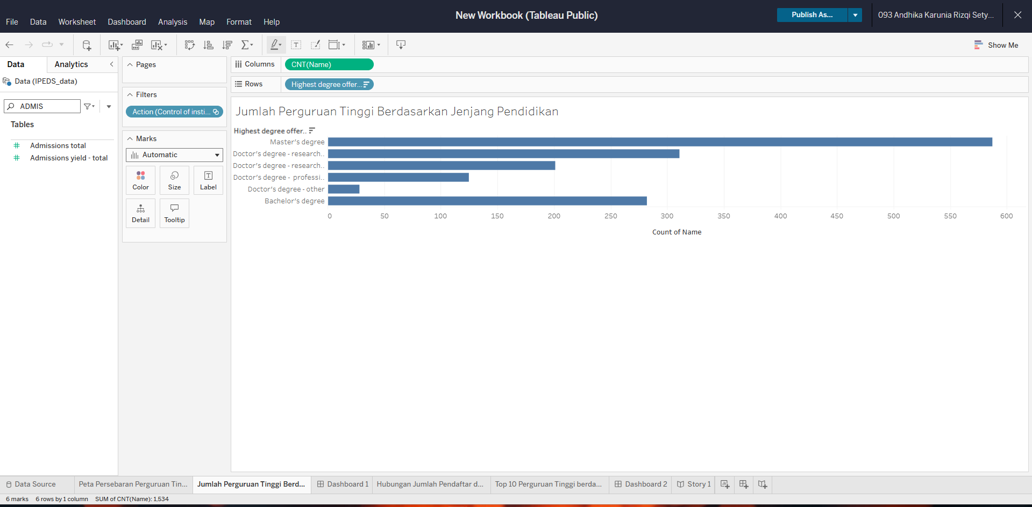

SHEET 3
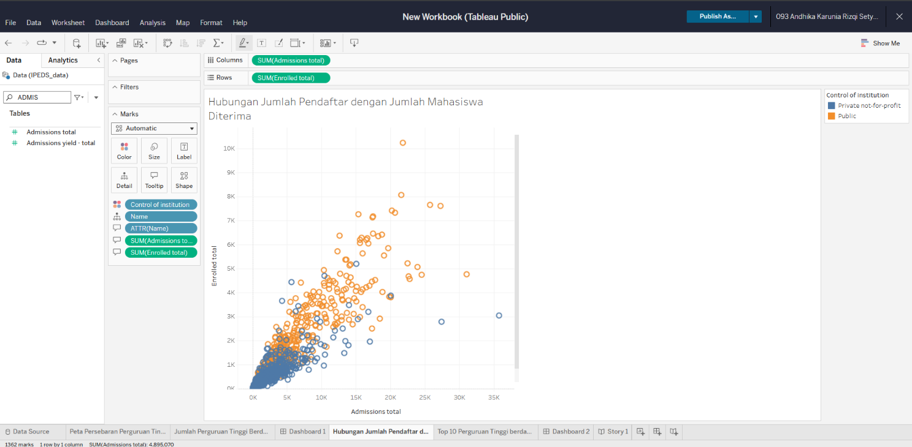

SHEET 4
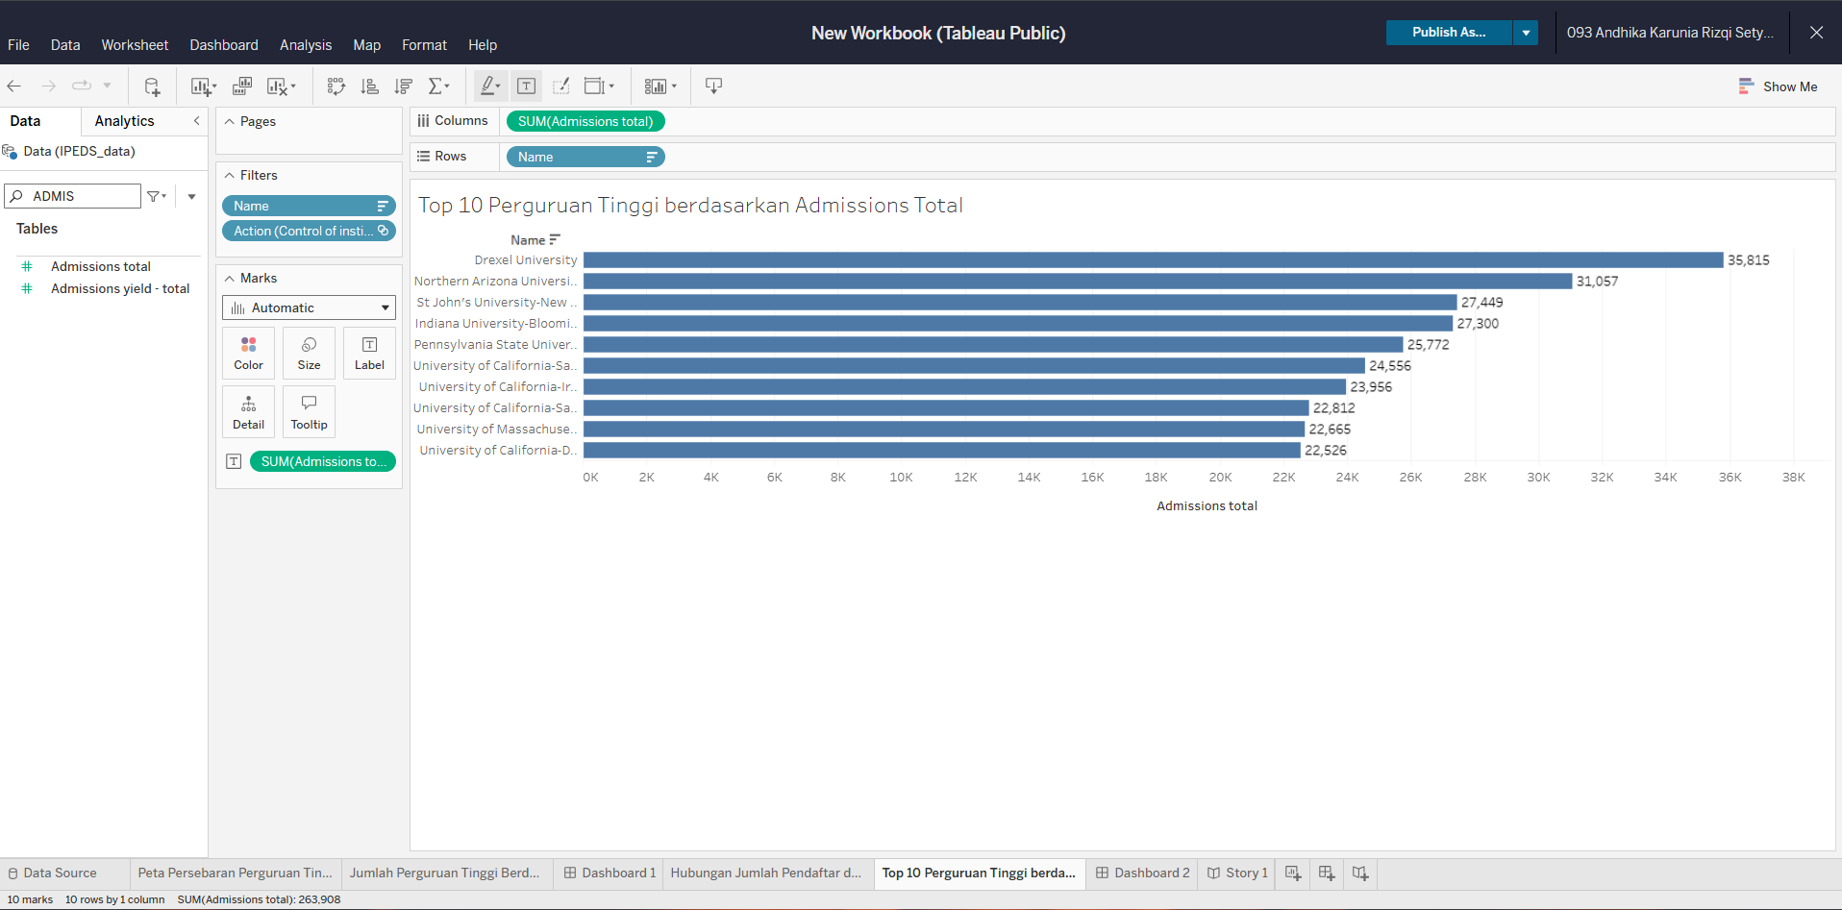

DASHBOARD 1
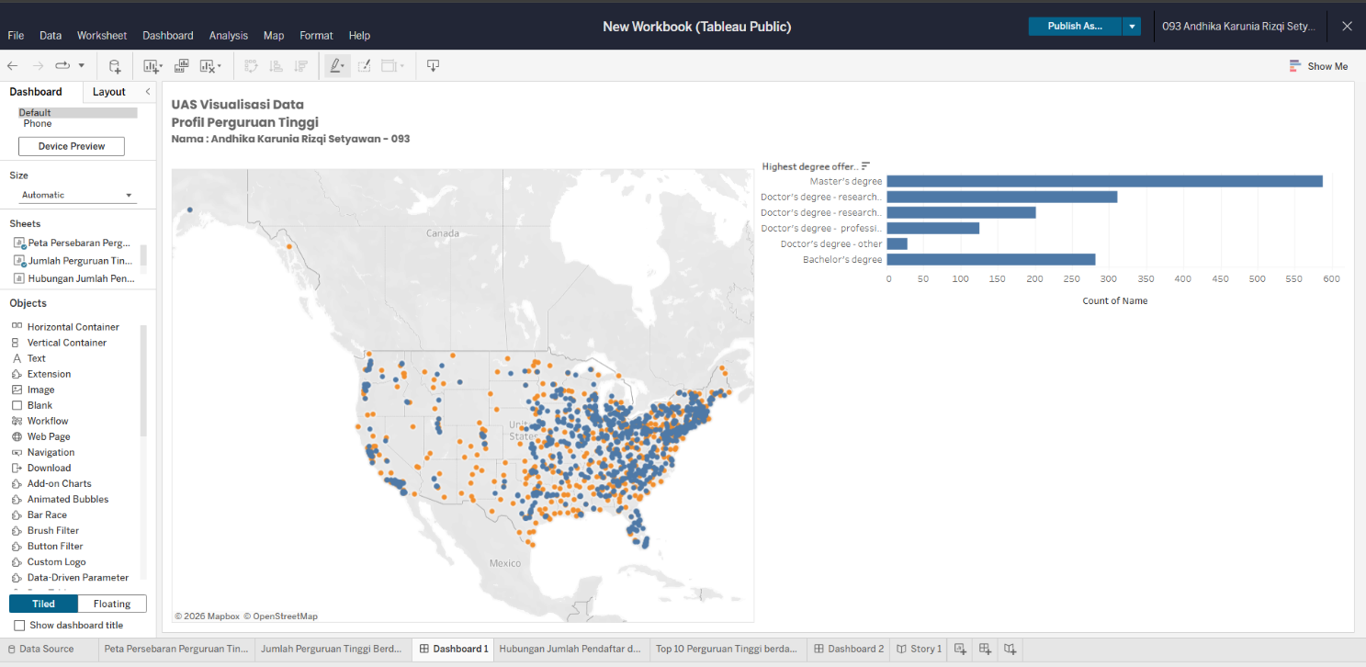

DASHBOARD 2
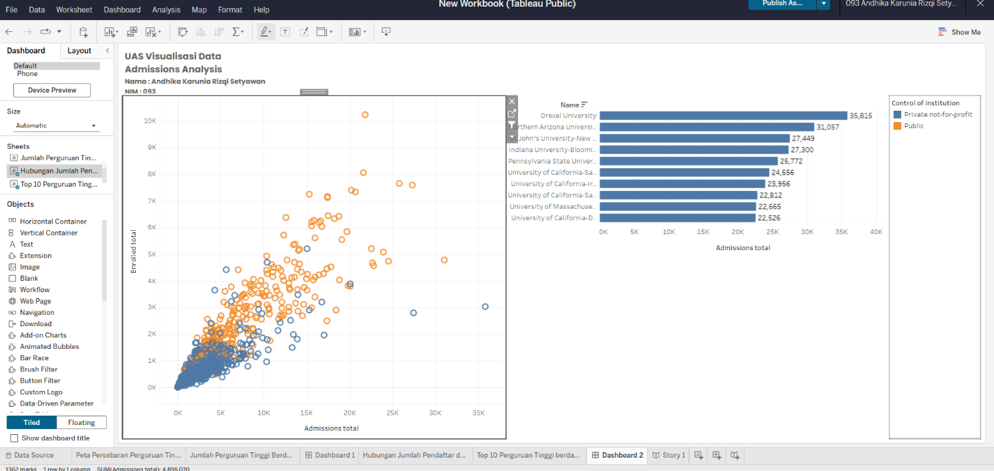

STORY
